**ONLINE EXAMINATION SYSTEM**

**Major Project Report**

**(MCA 4061)**

**Submitted in partial fulfillment of the requirement for the award of the degree of**

**Master of Computer Application**

*Submitted by*

Group No.: 20

Devesh Kumar Sharma (Univ. Roll No: 31222391603)

*Under the supervision of*

**Mr. Arpit Dubey**

*Assistant Professor*

**Department of Computer Application**

**School of Engineering & Technology (UIET)**



**Chhatrapati Shahu Ji Maharaj (CSJM) University**

**UP State University | Formerly Kanpur University**

**Accredited ‘A++’ by NAAC | UGC Category-I University**

**Kanpur (UP)**

**(2025)**

**DECLARATION**

I, **Devesh Kumar Sharma**, hereby declare that the work done in this Major Project (MCA-4061), has been carried out by me under the supervision of Mr. Arpit Dubey (Assistant Professor), Department of Computer Application, School of Engineering & Technology (UIET), Chhatrapati Shahu Ji Maharaj University (CSJMU), Kalyanpur, Kanpur.

Further, I declare that no part of this major project has been submitted either in part or full for the award of any degree to this university or any other university.

Date: (Devesh Kumar Sharma)

Place: (University Roll No.: 31222391603)



**Chhatrapati Shahu Ji Maharaj (CSJM) University**

**UP State University | Formerly Kanpur University**

**Accredited ‘A++’ by NAAC | UGC Category-I University**

**Kalyanpur, Kanpur (UP)**

**CERTIFICATE**

This is to certify that the Major Project Report entitled “**ONLINE EXAMINATION SYSTEM**” submitted by (**Devesh Kumar Sharma**| Gr. No.: 20) (University Roll No.: 31222391603) for the award of the degree of **Master of Computer Application** to the Department of Computer Application, School of Engineering & Technology (UIET), Chhatrapati Shahu Ji Maharaj University, Kanpur is a bonafide work carried out by ~~them~~/ him/ ~~her~~ under my supervision and guidance. It is further certified that ~~they~~/ he/ ~~she~~ ~~are~~/ is a bonafide student at this department of CSJM University.

Date:

Place: (Mr. Arpit Dubey)

|  |  |  |
| --- | --- | --- |
| (Prof. Rabins Porwal)  *Professor* | *Head*  Department of Computer Application  School of Engineering & Technology (UIET)  CSJM University, Kanpur |  | (External Examiner) |

Acknowledgement

I would like to take this opportunity to express my heartfelt gratitude and thanks to all those who have supported and guided me in the successful completion of my Major Project titled “**Online Examination System**.”

First and foremost, I extend my sincere thanks to my project mentor, **Mr. Arpit Dubey**, for his invaluable guidance, constant encouragement, and insightful feedback throughout the development of this project. His support has played a crucial role in shaping my ideas and helping me overcome various challenges during the course of this work.

I am also grateful to **Prof. Rabins Porwal**, Head of the Department of Computer Applications, CSJMU, Kanpur, for providing the necessary academic environment and resources that enabled me to carry out this project effectively.

My sincere appreciation goes to all the faculty members of the Department of Computer Applications for their continuous support, motivation, and the knowledge imparted throughout my academic journey.

I would also like to thank my friends for their constant encouragement, technical discussions, and moral support, which greatly contributed to the smooth execution of this project.

This project has been a valuable learning experience and a major milestone in my academic career.

Date: (**Devesh Kumar Sharma**)

Place: (University Roll No.: 31222391603)

# Table of Contents

Abstract 1

1. Introduction along with Literature Survey and Objectives 1

2. Methodology & Modules/ Software Requirement Specification & Project Designing 2

2.1 Technology (Hardware and Software) Used 4

Hardware Requirements: 4

Software Requirements: 4

2.2 Project Planning 5

2.3 Feasibility Study 9

Technical Feasibility 9

Economic Feasibility 9

Operational Feasibility 10

2.4 Design of the System 11

1. Use Case Diagram: 11

2. Use Case Description: 12

3. Entity Relationship Diagram: 15

4. Data Flow Diagrams (DFDs): 18

5. Logical Database Design: 20

6. High Level Structure Diagram: 22

3. Implementation/ Experimentation/ Project Development 24

3.1 Screen Shots & Functionality 24

1. Graphical User Interface: 24

4. Testing & Analysis 31

1. Testing Approach 31

2. Types of Testing Performed 31

3. Test Cases Overview 32

5. Deployment & Maintenance 33

1. Deployment Overview 33

2. Deployment Environment 33

3. Deployment Steps 33

4. Maintenance Activities 34

5. Future Maintenance Plans 34

6. Conclusion/ Results & Discussion 35

7. Applications & Advantages 36

Applications of Online Examination System: 36

Advantages of Online Examination System: 36

References 37

# List of Figures

Figure 1 - Use case Diagram 11

Figure 2 - ER Diagram 15

Figure 3 - Level 0 DFD 18

Figure 4- Level 1 DFD 19

Figure 5- Level 2 DFD 19

Figure 6 - Answers Table 20

Figure 7 -Courses Table 20

Figure 8 - Exams table 21

Figure 9 - Questions Table 21

Figure 10 - Test Table 22

Figure 11 - Users Table 22

Figure 12 - High level structure diagram 23

Figure 13 - Home Page 24

Figure 14- About Page 25

Figure 15 - Admin Login Page 26

Figure 16- Profile Page 27

Figure 17 - Courses Page 28

Figure 18 -Course Page 29

Figure 19 -Accounts Page 30

# List of Tables

Table 1 - Project Planning 6

Table 2 - Gantt Chart 6

Table 3 -Test Cases Overview 32

# Abstract

The **Online Examination System** is a web-based solution that revolutionizes traditional assessment methods by providing a secure, efficient, and scalable platform for conducting exams. Designed for educational institutions and organizations, the system replaces the need for paper-based exams, streamlining the process of creating, administering, and evaluating tests.

The system supports multiple user roles, including administrators and students, with secure authentication and role-based access. It enables administrators to manage question banks, schedule exams, and configure tests with multiple-choice.

Developed using technologies like HTML, CSS, JavaScript for the frontend and Java for the backend, with MySQL for database management, the system is designed to be scalable, user-friendly, and secure. The project was tested rigorously through multiple phases of testing including unit, integration, and system testing, and later deployed in a live or simulated environment.

This project not only reduces the administrative burden associated with paper-based exams but also enables examinations to be conducted remotely, making it ideal for institutions adopting online learning.

# 1. Introduction along with Literature Survey and Objectives

**The Online Examination System (OES)** is a software application designed to facilitate the administration, evaluation, and management of examinations over the internet. It serves as a robust alternative to traditional pen-and-paper-based assessments, addressing the growing need for digital transformation in educational institutions, certification authorities, and corporate training programs.

This system provides an efficient, secure, and user-friendly platform for conducting exams, enabling administrators to create and schedule tests, manage question banks, and oversee examination processes in a centralized manner. Students or candidates can access the system to take exams remotely, adhering to pre-set schedules and guidelines.

The primary objective of the OES [2] is to enhance the examination process by improving scalability, reducing logistical challenges, and minimizing errors associated with manual evaluation. It supports question formats, such as multiple-choice questions Automated grading and instant result generation streamline the post-exam process, offering quick feedback to candidates and saving significant administrative time.

The **Online Examination System** is a robust and efficient digital solution designed to streamline the process of conducting exams. It enables educational institutions, organizations, and corporations to administer tests in a secure, automated, and user-friendly environment.

This system eliminates the limitations of traditional paper-based exams by offering a web-based platform that facilitates:

* **Convenience**: Students can take exams from any location using internet-enabled devices.
* **Automation**: Features like automated grading, real-time results, and detailed analytics save time and reduce administrative overhead.

# 2. Methodology & Modules/ Software Requirement Specification & Project Designing

The project comprises several key modules, each designed to ensure a seamless and secure online examination experience for administrators, examiners, and students alike.

The **Authentication and Authorization Module** plays a critical role in ensuring secure access to the system. It provides login functionality for all user types—administrators, examiners, and students—while implementing robust role-based access control. This ensures that each user can only access the features relevant to their role, thereby enhancing the overall security of the platform.

The **Question Management Module** is responsible for the creation, editing, and management of the question bank. Administrators can use this module to maintain a well-organized repository of exam questions. It currently supports multiple-choice questions (MCQs), with potential for future extension to other formats.

To conduct examinations, the **Exam Management Module** offers essential functionalities such as scheduling exams and randomizing questions for each participant. It also includes time tracking capabilities and ensures automatic submission of responses once the allotted time expires. This reduces the chances of human error and helps maintain the integrity of the examination process.

Following the exam, the **Result Management Module** comes into action by automating the grading of objective-type questions. It also generates detailed performance reports for students and provides insightful analytics for administrators, which can be used for academic evaluation and system improvement.

To further reinforce the system's integrity, a **Security Module** has been incorporated. This module ensures encrypted data transmission and includes additional safeguards like IP-based access restrictions, automatic session timeouts, and the random sequencing of questions. These measures collectively minimize the risk of cheating and enhance trust in the platform.

The **Admin Dashboard Module** serves as the central control hub for administrators. It provides an intuitive interface to manage users, questions, and examinations. Moreover, it includes built-in analytics and reporting tools that assist in data-driven decision-making and system optimization.

Software Requirement Specification (SRS):

The **Software Requirement Specification (SRS)** outlines the essential functional and non-functional expectations from the system to ensure efficient and reliable performance.

From a **functional perspective**, the system must support secure user authentication along with role-based access control, allowing administrators, examiners, and students to access features specific to their roles.

It should also enable the management of a comprehensive question bank, facilitate the smooth conduct and monitoring of online examinations, and ensure automatic grading and timely generation of results.

On the other hand, the **non-functional requirements** focus on ensuring that the system remains highly available and reliable, even under heavy usage. It must be capable of scaling to support multiple users accessing the platform simultaneously.

Additionally, the user interface should be intuitive and user-friendly, catering to the varying needs of students, examiners, and administrators alike.

Project Designing:

In the **project designing phase**, [1] several design models were developed to visualize and streamline the system's architecture. The **Use-Case Diagram** captures the interactions between the various types of users—administrators, examiners, and students—and the system functionalities.

The **Data Flow Diagram (DFD)** illustrates how data moves through the system's different modules, offering clarity on internal processes and data handling.

The **Entity-Relationship Diagram (ERD)** defines the structure of the database, detailing the relationships among critical entities such as users, questions, and exams.

Finally, the **UI/UX design**  [6] focuses on creating responsive and accessible interfaces, ensuring that the platform is easy to navigate and performs consistently across a range of devices.

## 2.1 Technology (Hardware and Software) Used

### ****Hardware Requirements:****

**Server:**

Minimum 8 GB RAM

236 GB SSD storage

Intel® Celeron® N4500 @ 1.10 GHz (Dual Core)

**Client:**

Basic laptop, desktop PC, or smartphone

Stable internet connectivity

### ***Software Requirements***:****

**Backend:** Java, Servlets

**Development Tools:** NetBeans IDE, MySQL Workbench

**Frontend:**

HTML

CSS

JSP (Java Server Pages)

**Database:**

MySQL

**Server:**

Apache Tomcat

## 2.2 Project Planning

1. Objectives:

The main objective of this project is to build a comprehensive Online Examination System that addresses the growing need for digital transformation in the education and certification sectors. The system should not only replicate the functionality of traditional exams but enhance it by providing advanced features like real-time monitoring, automated evaluation, and analytics. Security, scalability, and ease of use are central to the system's design philosophy.

* To develop a secure platform that supports role-based login and access control for students, examiners, and administrators.
* To ensure the system can handle high traffic and multiple users concurrently without performance degradation.
* To simplify the complete examination lifecycle including exam creation, student enrollment, question management, and result generation.
* To integrate real-time analytics, enabling stakeholders to track student performance, exam integrity, and overall system usage.

2. Scope:

The scope of this project extends beyond a simple digital testing tool. It aims to provide an end-to-end solution that is suitable for a wide range of users and use cases, including academic institutions, professional certification bodies, and corporate learning departments. The system supports multiple exam formats, offers automated grading capabilities, and facilitates continuous monitoring to maintain exam integrity.

* The system is designed for deployment in schools, colleges, universities, certification boards, and corporate training environments.
* It supports a variety of question formats such as multiple-choice questions (MCQs), and can be extended to include subjective questions in the future.
* Users will be categorized into roles (student, examiner, administrator), each with specific permissions and functionalities.
* Administrators can create exams, assign examiners, manage student data, and access performance reports.

**3*. Project Phases and Timeline:***

**Table 1 - Project Planning**

|  |  |  |
| --- | --- | --- |
| **Phase** | **Task Description** | **Timeline** |
| **Requirement Gathering** | Identify user needs, functional and non-functional requirements, and document them. | Week 1-Week 2 |
| **System Design** | Create use-case diagrams, DFDs, ERDs, and wireframes for the system. | Week 3-Week 4 |
| **Development** | Implement modules: authentication, question management, exam management, results. | Week 5-Week 9 |
| **Testing** | Perform unit testing, integration testing, and system testing. | Week 10-Week14 |
| **Deployment** | Deploy the system on a web server and ensure operational readiness. | Week 15-Week17 |
| **Maintenance** | Monitor system performance and address bugs or updates. | Ongoing after launch. |

***Gantt Chart:***

**Table 2 - Gantt Chart**

|  |  |  |  |
| --- | --- | --- | --- |
| **Task** | **Start Date** | **End Date** | **Status** |
| Requirement Gathering | 28-July-2024 | 30-August-2024 | Completed |
| System Design | 01-September-2024 | 31-October-2024 | Completed |
| Development | 01-November-2024 | 15-January-2025 | Completed |
| Testing | 01-November-2024 | 20-January-2025 | Completed |
| Deployment | 21-January-2025 | 22-January-2025 | Completed |

**4. *Resource Allocation:***

Efficient resource allocation is essential for the successful execution of this project. Each team member is assigned a clear role, ensuring responsibilities are well-defined and tasks are executed with focus and accountability.

* **Project Manager**: Responsible for planning, supervising, and coordinating all phases of the project. Ensures adherence to timelines, quality standards, and communication.
* **Backend Developer**: Handles the server-side logic, API development, database integration, and ensures secure and optimized performance of all backend functionalities such as authentication, exam logic, and result processing.
* **Frontend Developer**: Designs and implements the user-facing components of the system. Ensures the interface is intuitive, responsive, and compatible across devices and browsers. Works closely with the backend developer to ensure smooth integration.
* **QA Tester**: Develops and executes test plans and scripts for unit, integration, and system testing. Identifies bugs and performance issues to ensure the system functions reliably under all expected use cases.
* **Database Administrator (DBA)**: Designs the database schema, optimizes queries, ensures data consistency, and manages backups and recovery. Also handles the security of stored data and monitors performance under load.

**5. *Risk Management:***

Risk management is a critical part of the project, addressing these risks early allows the team to maintain system integrity, security, and performance even under unforeseen circumstances.

* **Security Risks:** Given the sensitive nature of exam data and user credentials, the system must defend against unauthorized access, data breaches, and impersonation. These threats are addressed by using robust encryption protocols, secure login mechanisms, and strict role-based access controls.
* **System Overload:** During peak times, especially during mass examination sessions, the system may experience high traffic, leading to performance lags or crashes. To mitigate this, the system architecture is designed to be scalable and optimized, with provisions for load balancing and performance monitoring tools.
* **Data Loss:** The risk of data loss due to hardware failure, accidental deletion, or software bugs is minimized by implementing regular automated database backups, using stable version control systems, and having a disaster recovery plan in place.
* **Development Delays:** Delays can occur due to unforeseen technical issues or human resource constraints. A structured project timeline with built-in buffer periods, along with agile development practices, ensures flexibility and allows the team to adapt and respond efficiently to any delays.

**6*. Deliverables:***

The project will result in a complete Online Examination System along with essential documentation and deployment support. These deliverables ensure the system is ready for use and easy to maintain.

Online Examination System with modules for login, exam creation, question management, and result generation.

Documentation including:

* **SRS Document**
* **User Manual**
* **Technical Documentation**
* **Deployment** on an Apache Tomcat server for live usage.
* **Maintenance Plan** covering updates, bug fixes, and user support post-deployment.

**7*. Success Criteria:***

The success of the project will be measured by system performance, user satisfaction, and functionality as per requirements.

* Successful and timely deployment of the system.
* Smooth user experience with intuitive navigation.
* Secure, glitch-free exam conduction under expected load.
* Positive feedback from students, examiners, and administrators.

## 2.3 Feasibility Study

A feasibility study is crucial to evaluate whether the proposed Online Examination System can be successfully developed and implemented within the available constraints. It analyzes the project from multiple perspectives—technical, economic, operational, legal, and risk-based—to ensure that the solution is practical, sustainable, and scalable.

Technical Feasibility  
The technical feasibility examines whether the required technological infrastructure and expertise are available to develop and deploy the system.

The Online Examination System is designed as a web-based application compatible with desktops, tablets, and smartphones, requiring stable internet connectivity for all users.

The backend architecture must support real-time processing and data storage, typically hosted on scalable cloud services. If the target organization already has basic infrastructure like web hosting and database servers, implementation becomes more straightforward.

However, challenges such as maintaining platform compatibility across devices and managing server load during peak exam times must be addressed.

With modern solutions like AWS, Google Cloud, or Azure, these challenges can be effectively managed, making the system technically viable.

Economic Feasibility  
Economic feasibility evaluates whether the project is cost-effective and offers a reasonable return on investment. The initial cost includes development expenses, server setup, licensing of third-party tools (if any), and future maintenance.

Despite these costs, the system provides long-term savings by eliminating manual processes like exam printing, invigilation logistics, and paper-based grading. Additionally, the platform supports scalability, allowing multiple users to access services remotely, which is especially beneficial for institutions operating across geographies.

Through a break-even analysis, it is evident that the upfront investment can be recovered over time due to the reduction in administrative workload and operational costs.

Hence, the project is considered economically feasible.

Operational Feasibility  
Operational feasibility focuses on whether the system can function smoothly within the users’ daily workflows and meet their practical needs. The system caters to students, examiners, and administrators by offering a clear, intuitive user interface and robust functionality.

Students benefit from accessible exam portals with structured instructions, while examiners can create and manage tests efficiently. Administrators gain insights and control through streamlined dashboards and reporting tools.

Potential challenges include training users—especially examiners and administrators—to use the system effectively and ensuring smooth real-time handling of exams and submissions. With proper onboarding and user support, the system can be smoothly integrated into existing operations, making it highly operationally feasible.

Legal Feasibility  
Legal feasibility determines whether the system complies with existing laws and regulations concerning data privacy, licensing, and accessibility. Since user data—such as credentials, performance records, and exam results—is sensitive, the system must adhere to data protection laws like GDPR (Europe), CCPA (California), or India's data privacy frameworks.

Secure encryption and controlled access to personal data are essential. Additionally, all third-party libraries or tools used must be properly licensed to avoid legal complications. Accessibility is another key concern; the platform should comply with the Web Content Accessibility Guidelines (WCAG) to ensure usability for differently-abled users.

Risk Feasibility  
Risk feasibility assesses potential threats to the project and how effectively they can be mitigated. The major risks include cybersecurity issues such as unauthorized access or cheating, server failures during exam sessions, and resistance to change from stakeholders accustomed to traditional exam methods.

These can be mitigated through strong authentication mechanisms, data encryption, session tracking, and IP-based restrictions.

Additionally, robust server monitoring, regular data backups, and technical support are essential for ensuring system availability. To encourage adoption, awareness and training sessions can help stakeholders understand the benefits of the new system.

## 2.4 Design of the System

### 1. Use Case Diagram:

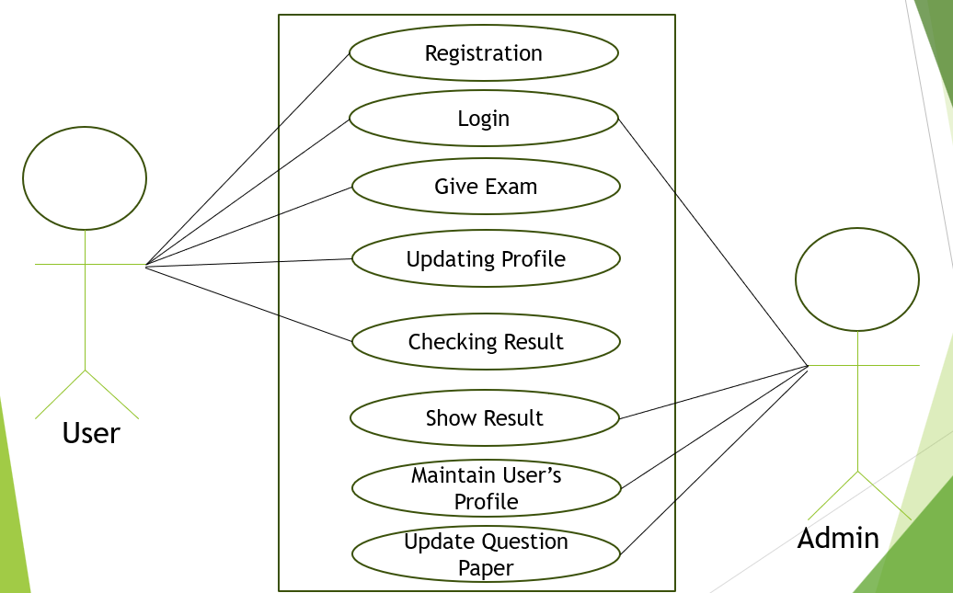

**Figure 1 - Use case Diagram**

### 2. Use Case Description:

**1. Registration**

In this use case, users (students) can register for the system by providing essential details such as their name, email, contact number, and other credentials. The registration process is a necessary step for users to access the system.

* **Actor(s)**: User
* **Description**: Users (students) provide necessary details like name, email, and contact number to register for the system.
* **Precondition**: The user should not already be registered.
* **Postcondition**: A new user account is created, and login credentials are generated for the user.

**2. Login**

This use case describes the process where both users and administrators log in to the system using valid credentials. The login is required to gain access to the respective dashboard based on the user role.

* **Actor(s)**: User, Admin
* **Description**: Users and administrators log into the system with their registered credentials to access the system.
* **Precondition**: The user or admin must be registered in the system.
* **Postcondition**: The user or admin is granted access to their respective dashboards.

**3. Give Exam**

In this use case, registered users can attempt scheduled exams within the system. The system tracks the duration of the exam and records responses from the users for evaluation.

* **Actor(s)**: User
* **Description**: Registered users can access and attempt scheduled exams. The system monitors the time taken for the exam and tracks the answers.
* **Precondition**:
* The user must be logged in, and the exam must be scheduled and accessible to user.
* **Postcondition**: The user submits their responses, and the system records the answers for evaluation.

**4. Updating Profile**

This use case allows users to update their profile information, such as their name, email, and contact details. This feature ensures that users can maintain up-to-date information in the system.

* **Actor(s):** User
* **Description**: Users can update personal details like their name, email, and contact number within their profiles.
* **Precondition:** The user must be logged into their account.
* **Postcondition**: The updated user profile is saved and reflected in the system.

**5. Checking Result**

Users can check the results of their exams once they have been published. This feature allows students to review their performance after an exam.

* **Actor(s):** User
* **Description**: After exams are completed, users can access and check their results once they are published in the system.
* **Precondition:**
* The user must have attempted an exam.
* Results must have been generated and be available for viewing.
* **Postcondition**: The user can view their score and exam performance details.

**6. Show Result**

This use case involves administrators who are responsible for publishing exam results once the grading process is complete. Admins have control over when results are visible to users.

* **Actor(s)**: Admin
* **Description**: Admins can publish the results of exams after the grading process is completed, making the results available to students.
* **Precondition**: The admin must ensure the examination grading is complete.
* **Postcondition**: The results are made visible to users for checking

**7. Maintain User’s Profile**

Admins can manage user profiles by adding, updating, or removing users from the system. This use case is critical for maintaining an up-to-date database of all users.

* **Actor(s):** Admin
* **Description:** Admins have the ability to manage user profiles, including adding new users, updating their information, or removing inactive users.
* **Precondition:** The admin must be logged into their account.
* **Postcondition**: User profiles are updated or managed as required.

**8. Update Question Paper**

Admins are able to update, add, or delete questions in the question bank. This ensures that the exam content is always fresh and relevant for the students.

* **Actor(s):** Admin
* **Description**: Admins can create, modify, or delete questions in the question bank used for conducting exams.
* **Precondition**: The admin must be logged into the system.
* **Postcondition**: The question bank is updated and ready for use in upcoming exams.

### **3. Entity Relationship Diagram**:

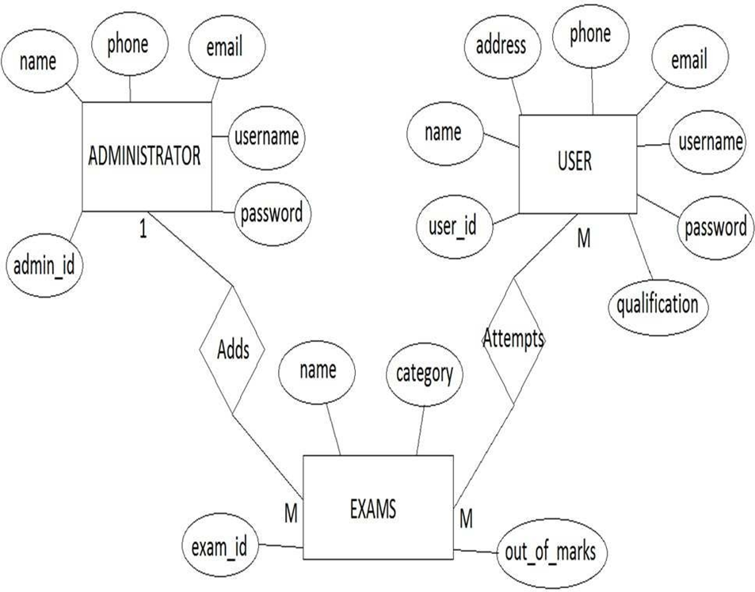

**Figure 2 - ER Diagram**

E-R Diagram Description:

**1*.* Administrator**

Attributes:

* Name*:* Name of the administrator.
* Phone*:* Phone number of the administrator.
* Email*:* Email address of the administrator.
* Username*:* Username for login.
* Password: *Password for secure access.*
* Admin-id*:* Unique identifier for the administrator (Primary Key).

**Relationship:**  
The administrator can Add exams. This is a one-to-many relationship, as one administrator can add multiple exams.

**2. User**

Attributes:

* Name: Name of the user.
* Address: Address of the user.
* Phone: Phone number of the user.
* Email: Email address of the user.
* Username: Username for user login.
* Password: Password for secure user access.
* User - id: Unique identifier for the user (Primary Key).
* Qualification: Educational qualification of the user.

**Relationship:**

A User can Attempt multiple exams. This is a many-to-many relationship, meaning a user can attempt many exams, and each exam can be attempted by many users.

**3. Exam**

Attributes:

* Exam-id: Unique identifier for each exam (Primary Key).
* Name: Name of the exam.
* Category: Category of the exam (e.g., subject, difficulty level).
* Out of marks: Maximum possible score for the exam.

**Relationship:**

The Exam is Added by the administrator. One administrator can add multiple exams.

Users can Attempt exams, indicating that exams can be taken by multiple users, and each user can attempt multiple exams.

**Relationships and Cardinality:**

**Administrator – Adds -> Exams (1 to M):**  
An administrator has the privilege to add multiple exams to the system. One administrator can add several exams, but each exam is added by only one administrator.

**User – Attempts -> Exams (M to M):**A user can attempt many exams, and each exam can be attempted by many users. This many-to-many relationship indicates that a user can participate in multiple exams, and each exam can have multiple users.

### 4. Data Flow Diagrams (DFDs):

4.1. Context Diagram or Level-0 DFD:

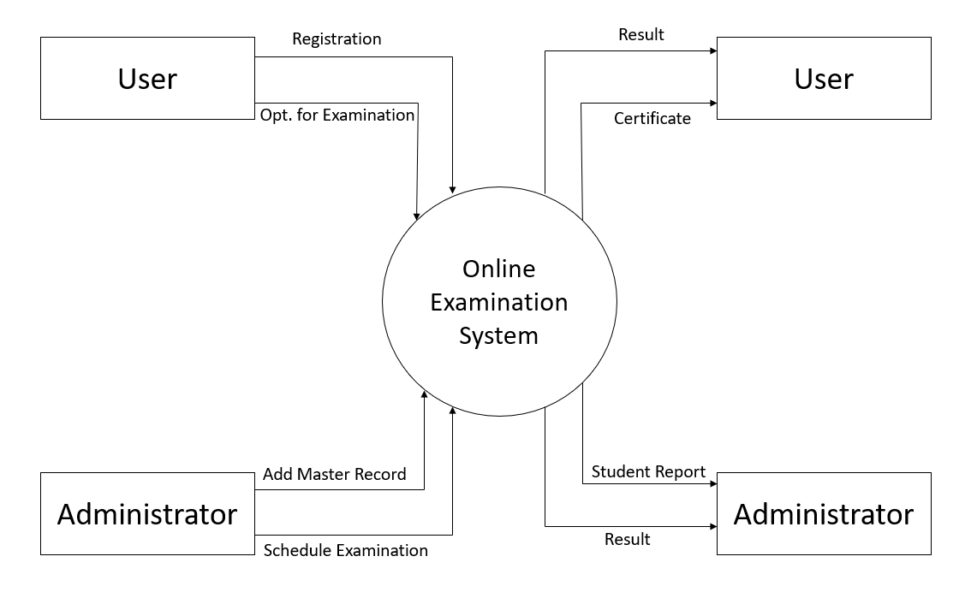

**Figure 3 - Level 0 DFD**

4.2. Level-1 DFD:

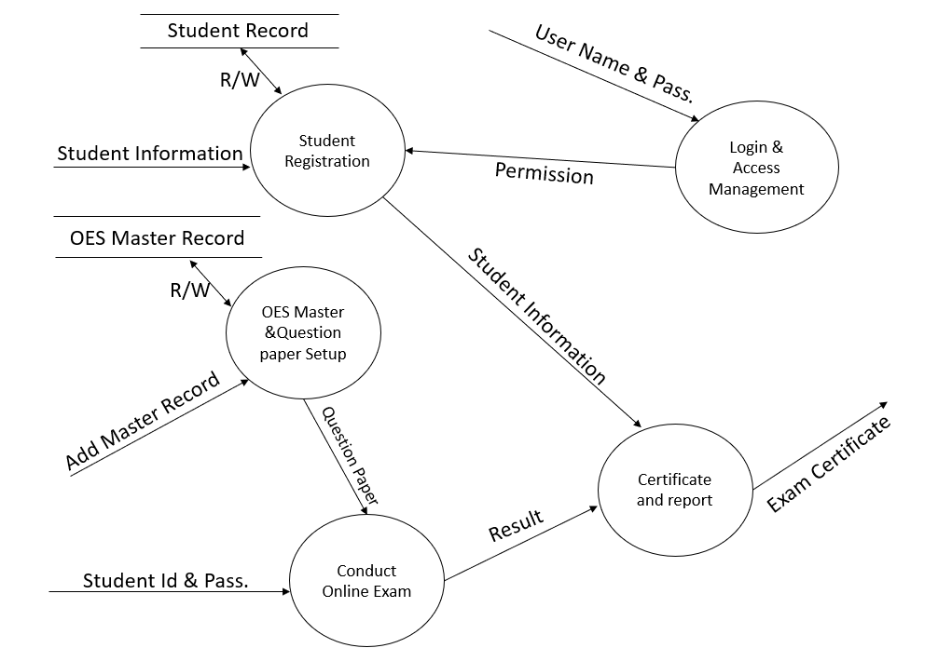

**Figure 4- Level 1 DFD**

4.3. Level-2 DFD:

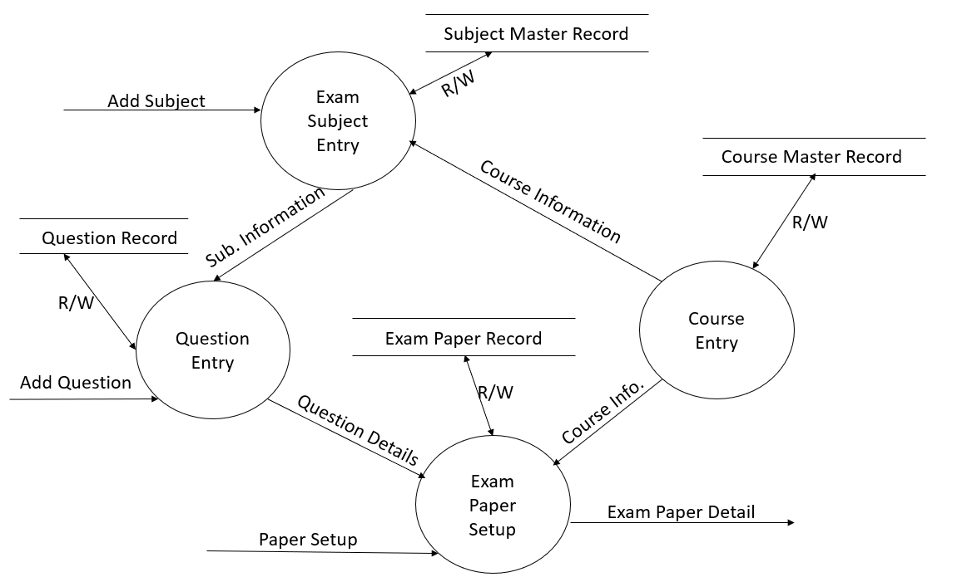

**Figure 5- Level 2 DFD**

### 5. Logical Database Design:

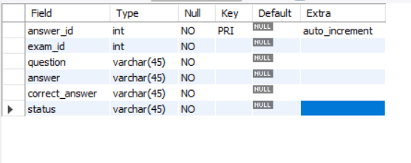

**Figure 6 - Answers Table**

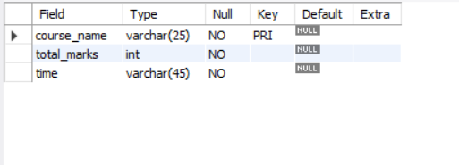

**Figure 7 -Courses Table**

***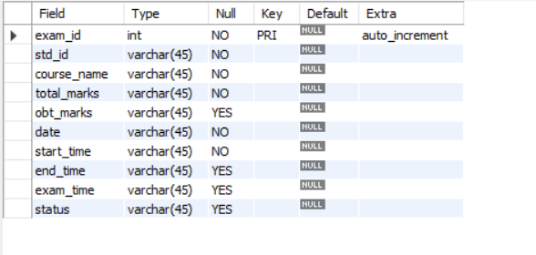*****Figure 8 - Exams table**

***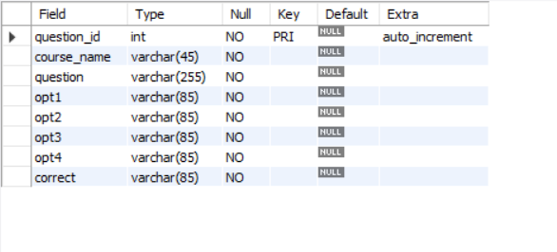*****Figure 9 - Questions Table**

***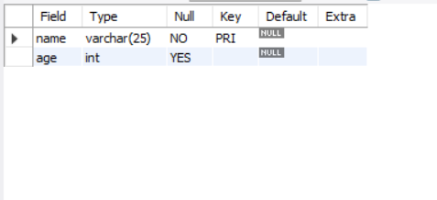*****Figure 10 - Test Table**

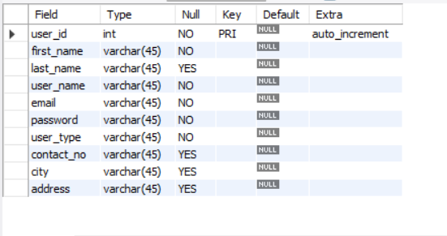

**Figure 11 - Users Table**

### 6. High Level Structure Diagram:

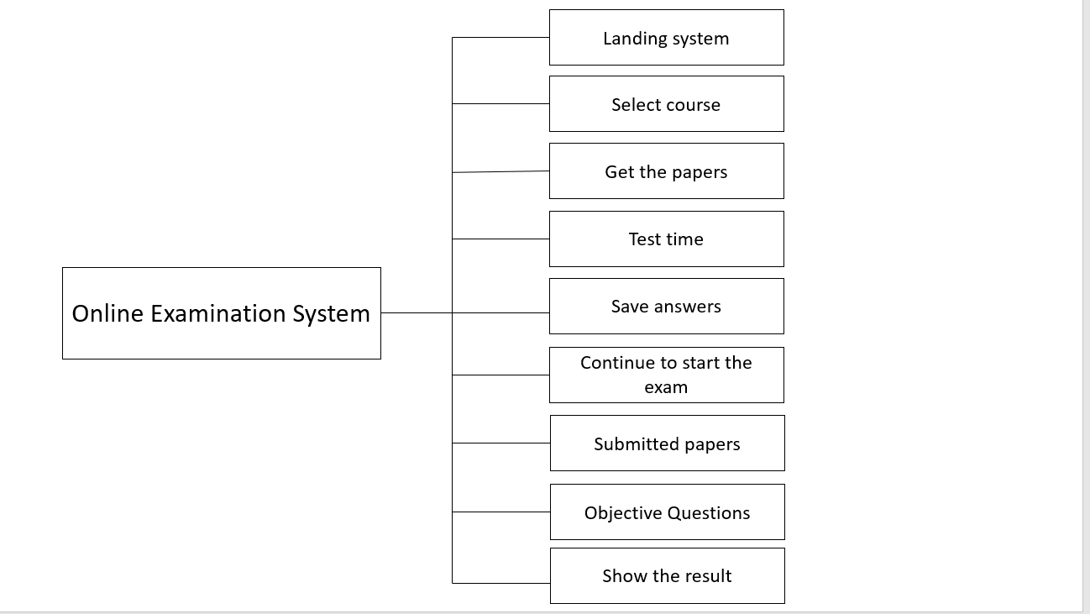

**Figure 12 - High level structure diagram**

# 3. Implementation/ Experimentation/ Project Development

## 3.1 Screen Shots & Functionality

### ***1. Graphical User Interface***:

**Figure 13 - Home Page**



**Figure 14- About Page**



**Figure 15 - Admin Login Page**



**Figure 16- Profile Page**

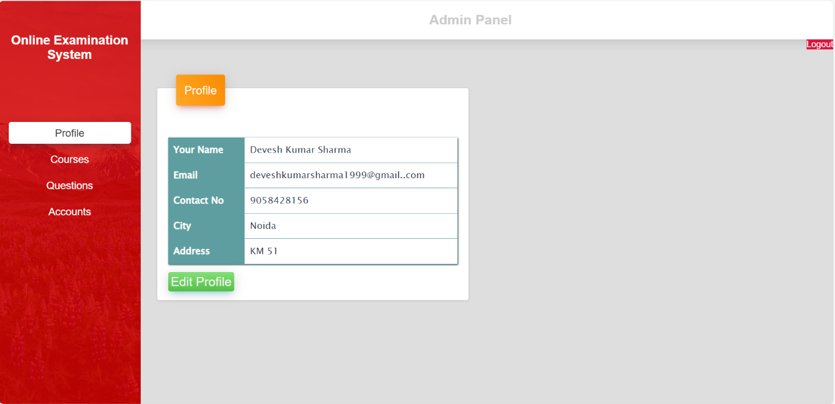

**Figure 17 - Courses Page**

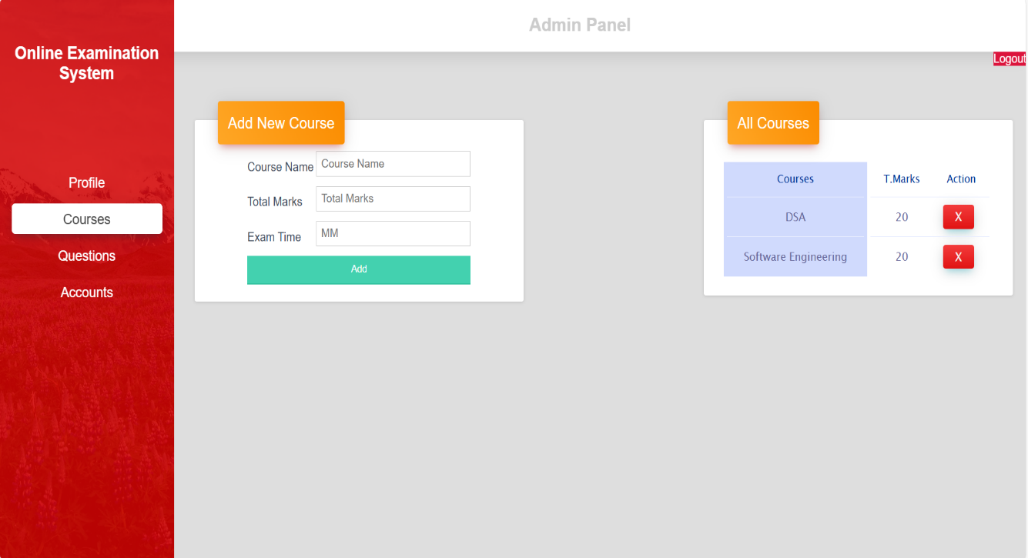

**Figure 18 -Course Page**

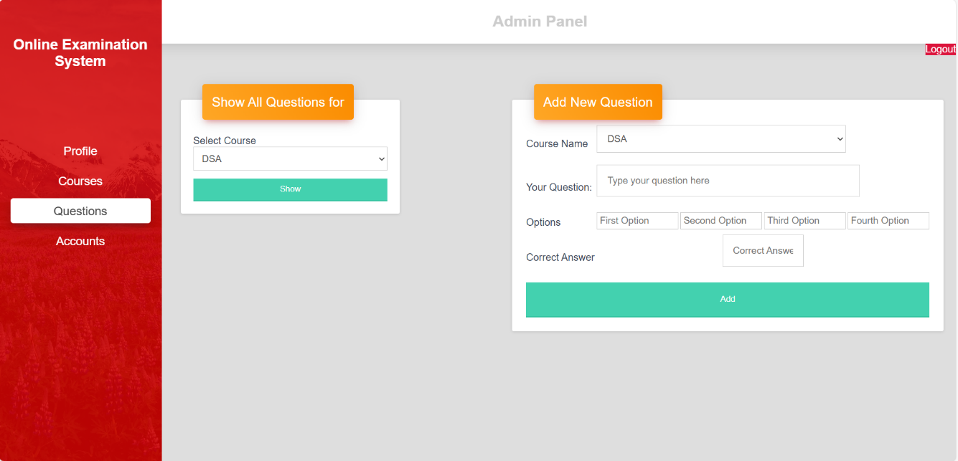

**Figure 19 -Accounts Page**

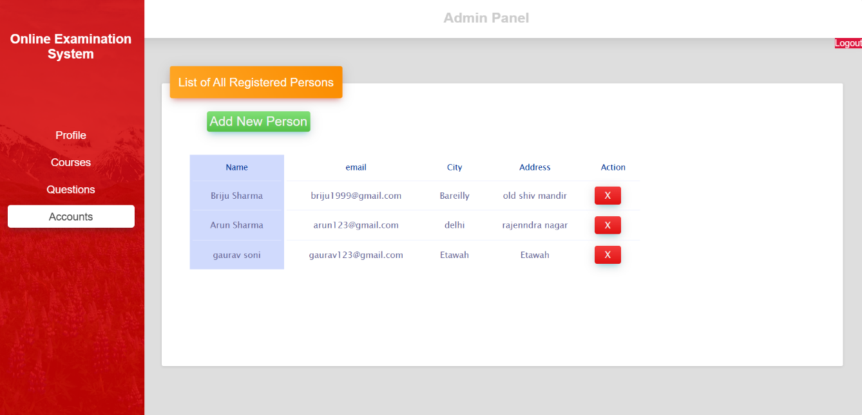

# 4. Testing & Analysis

## 1. Testing Approach

To ensure the reliability and accuracy of the Online Examination System, both manual and automated testing methods were used. The system was tested [9] under various scenarios to check its performance, functionality, and security.

## 2. Types of Testing Performed

These are the types of testing performed to check the Online Examination System :

* **Unit Testing**:  
  Each module such as login, question loading, answer submission, and result generation was tested independently to verify correct functionality.
* **Integration Testing**:  
  The interaction between modules like user login and exam dashboard, or exam submission and result generation was tested to ensure smooth data flow.
* **System Testing:**The complete system was tested in a simulated environment to verify that all modules work together as expected.
* **User Acceptance Testing (UAT):**A group of users tested the system for usability, ensuring that the UI is intuitive and meets the functional requirements.
* **Performance Testing:**The system was tested for response time during peak usage to ensure that it can handle multiple concurrent users.
* **Security Testing:**  
  Ensured that user data is encrypted, unauthorized access is restricted, and sessions are handled securely.

## 3. Test Cases Overview

|  |  |  |  |  |
| --- | --- | --- | --- | --- |
| **Test Case ID** | **Description** | **Expected Result** | **Actual Result** | **Status** |
| TC01 | Login with valid credentials | Dashboard should load | Dashboard loaded | Pass |
| TC02 | Attempt exam with timer enabled | Timer should countdown & auto-submit | Timer worked as expected | Pass |
| TC03 | Submit exam before time | Exam should submit & result shown | Success | Pass |
| TC04 | SQL injection in login form | System should block the attempt | Blocked | Pass |
| TC05 | Concurrent users taking exams | System should handle simultaneous users | No lag or failure | Pass |

**Table 3 -Test Cases Overview**

## 4. Bug Tracking & Resolution

During testing, minor bugs were found such as UI misalignment on mobile screens and incorrect timer display under rare conditions. These were resolved through code adjustments and re-tested.

## 5. Analysis

* The system met all functional requirements.
* Performance remained stable with up to 100 concurrent users.
* Security protocols like session management and input validation worked as intended. Users found the interface easy to navigate during the UAT.

## 6. Tools Used for Testing

* Selenium (for automated testing)
* Postman (for API testing, if applicable)
* Browser Dev Tools (for UI/UX debugging)

# 5. Deployment & Maintenance

## 1. Deployment Overview

After successful development and testing of the Online Examination System, the application was deployed for real-time access by users. The deployment process involved setting up the server environment, configuring the database, and ensuring that all system components work correctly in the production environment.

## 2. Deployment Environment

* **Web Server**: Apache (via XAMPP/WAMP) or hosted on a cloud platform (e.g., AWS, Heroku)
* **Database**: MySQL or any other RDBMS
* **Backend Language**: Java / Python (choose based on what you used)
* **Frontend:** HTML, CSS, JavaScript
* **Hosting Type**: Localhost / Cloud-based deployment

## 3. Deployment Steps

* **Code Packaging**:  
  All source code, assets, and dependencies were organized and prepared for deployment.
* **Server Configuration**:  
  The server was configured to support the technology stack used. PHP modules, database access, and runtime environments were set up.
* **Database Setup**:  
  The database schema was imported, and initial data was seeded. Proper user roles and permissions were configured.
* **Code Upload**:  
  The application files were uploaded to the server using FTP/SFTP or through a deployment tool.
* **Testing in Production**:  
  Post-deployment testing was conducted to ensure that all functionalities worked correctly in the live environment.
* **Security Measures**:  
  Basic security configurations such as HTTPS, input validation, and session handling were implemented.

## 4. Maintenance Activities

* **Bug Fixes & Patches**:  
  After deployment, minor bugs reported by users were quickly addressed and patched.
* **Database Backups**:  
  Regular backups of the database were scheduled to prevent data loss.
* **Performance Monitoring**:  
  Server performance and system response time were monitored to ensure a smooth user experience.
* **User Support**:  
  Feedback from users was collected, and support was provided for any technical difficulties.
* **System Updates:**  
  Updates were periodically made to improve security, enhance performance, and add new features.

## 5. Future Maintenance Plans

* Add automatic email notifications for exam results.
* Implement advanced analytics for tracking user performance.
* Periodic updates for UI/UX improvements.
* Migrate to scalable cloud infrastructure if user base grows.

# 6. Conclusion/ Results & Discussion

The **Online Examination System** represents a significant advancement in assessment processes, providing a modern, efficient, and scalable solution for evaluating knowledge and skills. By leveraging technology, this system addresses the limitations of traditional examination methods, offering a seamless experience for both administrators and participants. Its features, such as automated grading, enhanced security, and accessibility, make it an essential tool for educational institutions, corporations, and certification bodies. As the world embraces digital transformation, the adoption of online examination systems is pivotal for improving the quality, efficiency, and reach of assessments.

Results

The implementation of the Online Examination System demonstrates several positive outcomes:

**Efficiency in Test Management**

Reduced administrative burden through automation of processes like scheduling, grading, and result generation.

**Enhanced Accessibility**

Increased participation rates due to location and time flexibility.

**Improved Security**

Reduction in malpractices owing to features like proctoring, user authentication, and question randomization.

**Faster Feedback**

Immediate results allow participants to understand their performance and focus on areas for improvement.

**Cost Savings**

Significant reduction in costs related to printing, logistics, and physical infrastructure.

# 7. Applications & Advantages

## Applications of Online Examination System:

**Educational Institutions**

* Conducting semester exams, quizzes, and entrance tests.
* Assessing student progress and understanding through periodic evaluations.

**Recruitment and Corporate Training**

* Conducting aptitude and skill-based tests for hiring processes.
* Organizing certification programs and employee training assessments.

**Certification Authorities**

* Administering professional certification exams, such as language proficiency tests or industry-standard certifications.[4]

**Remote Learning Platforms**

* Enabling assessments for e-learning courses to validate learning outcomes.

**Government and Competitive Exams**

* Hosting large-scale tests like public service exams, competitive entrance tests, or license qualification exams.

## Advantages of Online Examination System:

**Convenience and Accessibility**

* Allows candidates to take exams from any location with an internet connection.
* Supports various devices, including desktops, laptops, and mobile phones.

**Time and Cost Efficiency**

* Reduces costs associated with printing, logistics, and manual evaluation [5].
* Speeds up the process of result generation through automated grading.

**Enhanced Security**

* Implements authentication methods to verify candidate identity.
* Features like question randomization and time tracking help prevent cheating.

# References

[1] A. Sharma, *Design and Implementation of Online Examination Systems*, 1st ed., New Delhi, India: TechPress, 2020, pp. 101–120.

[2] V. Kumar and R. Mehta, *E-Learning and Online Assessment Technologies*, 2nd ed., Mumbai, India: EduWorld Publications, 2019, pp. 55–89.

[3] M. S. Khan, *Web Technologies for Online Exams*, 3rd ed., Hyderabad, India: Digital Press, 2021, pp. 22–78.

[4] K. R. Patel, *Secure Web Applications: A Guide for Developers*, 1st ed., Bengaluru, India: CyberTech Books, 2018, pp. 132–150.

[5] S. Tiwari, *Modern Educational Systems: Digital Classrooms and Examinations*, 1st ed., Pune, India: Scholar Publishing House, 2022, pp. 65–110.

[6] J. Peters, Ed., *Advances in Educational Technologies*, 2nd ed., vol. 3, New York: McGraw-Hill, 2017, pp. 15–64.

[7] P. C. Jha and A. Mishra, *Online Examination Systems: Concepts and Implementation*, 1st ed., Delhi, India: EduTech Publications, 2020, pp. 75–130.

[9] N. Rajput, *Web-Based Testing Systems and Architecture*, 1st ed., Chennai, India: Technovate Publishers, 2021, pp. 101–142.

[10] T. K. Ghosh, *Information Systems in Education*, 3rd ed., Kolkata, India: Academic World Press, 2018, pp. 210–260.